Kurwongbah State School

Whole School Approach to Differentiated Teaching and Learning

2019 - 2020
At Kurwongbah State School, all students are encouraged to become responsible, confident, self- motivated and co-operative individuals who aspire to achieve their maximum potential within a safe and supportive setting. Our focus is on the whole child, including academic, physical, social and emotional facets. We are committed to the success of all students through a deep understanding of the strengths of each individual, identified needs through data and evidence-based response strategies delivered through differentiated teaching and learning.
Kurwongbah is an inclusive school where everyone has a place, is heard, respected, accepted and has agency. Everyone is seen to have inner strengths and is given the opportunity to develop their strengths and assistance is provided when needed. Everyone is welcome at all times by all members of our school community. Classrooms embrace student diversity, celebrate personal successes and thrive on the collective contributions of all members. Every student knows they have advocates and have a strong connection as a valued member of the whole school community.
At Kurwongbah State School, we use a whole school approach to support different levels of student needs. Three layers provide a continuum of support with increasingly focused and personalised teaching and intervention at each successive layer – including increasing levels of adjustments, monitoring of student learning and behaviour and involvement of support staff.
The appropriate layer of support is identified through analysis of student data and ongoing monitoring of student progress. Whole school data identifying students’ disability area and level of adjustments is collected and reviewed annually through the Nationally Consistent Collection of Data process. Parents are seen as critical partners with the school in children’s learning and, as such, any adjustments are implemented in consultation with parents through a collaborative process. All documentation outlining adjustments for students is recorded in One School for reference over time. This process works in conjunction with the Kurwongbah State School Student Services team to review identified student needs and target response resources to maximise potential for all students.
Kurwongbah State School Student Services team comprises: Principal, Deputy Principal, Head of Diverse Learners, Speech Language Pathologist, Guidance Officer, STEM, Behaviour and Enrichment Teachers. Teachers record class data in a Register of Concerns outlining key areas of student need. The team meets regularly to case manage students by identifying response strategies, aligning resources and reviewing progress over time. The Register of Concerns is reviewed in conjunction with A-E and NCCD data sets. Highly effective response strategies are recorded for feedback and future reference for teachers. Consideration is given to prevention and response strategies.
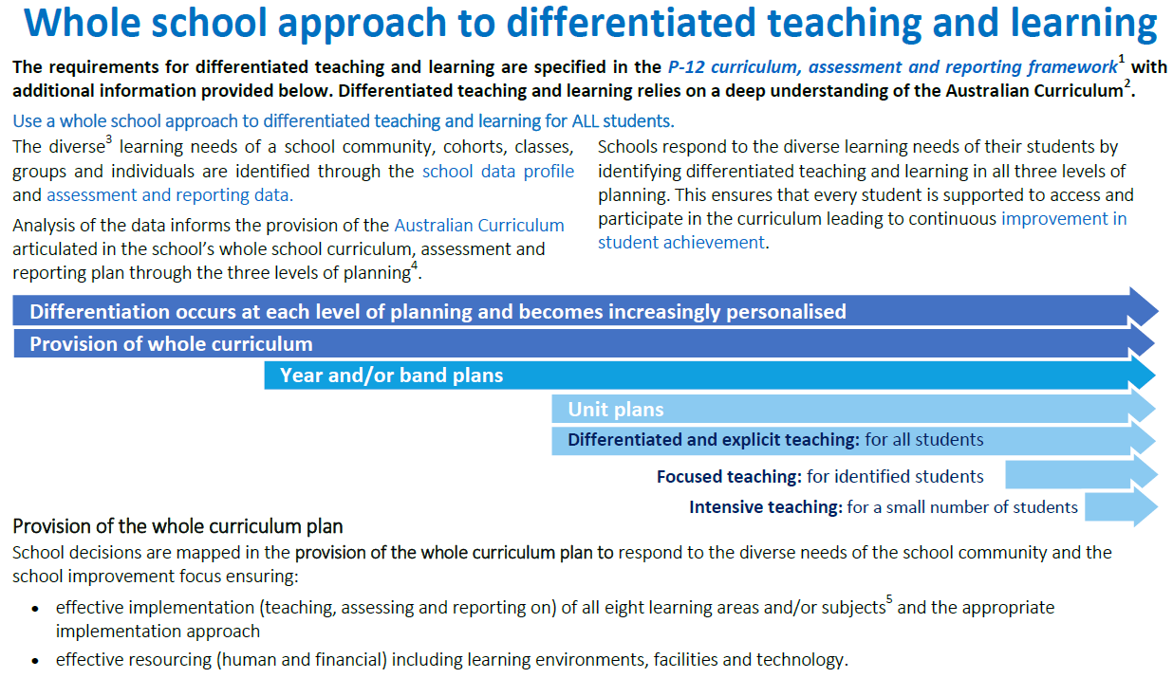
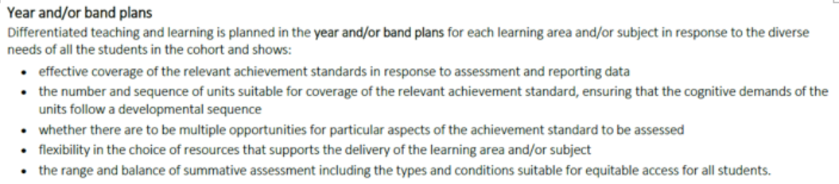
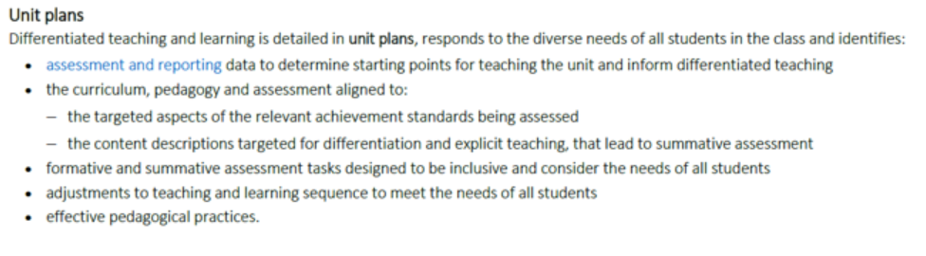
Differentiated Teaching and Learning requires a deep knowledge of student’s evidence of progress, a breadth of responsive, engaging pedagogical strategies and a collective ownership of student improvement beyond just the classroom teacher. Differentiated Teaching and Learning embraces high yield improvement strategies purposefully leading learning to ensure students own their personal steps to success. Key documentation for this phase includes:
- Kurwongbah State School Whole School Curriculum Plan
- Kurwongbah State School Assessment and Reporting Framework including Data Schedule
- Kurwongbah State School Pedagogical Framework
- Kurwongbah State School Reading, Writing and Spelling Frameworks
- Teacher planning including planned differentiation and adjusted assessment tasks reflecting reasonable adjustments for students
- One School Class Dashboard, Class Groupings including learning goals and high yield strategies
- Whole School PBL term overviews with behaviour, social/emotional and learning strategies
Prevention Strategies may include:
At planning phase:
- Comprehensive knowledge of student learning data: diagnostic, formative and summative
- Comprehensive knowledge of curriculum expectations including assessment success criteria and the underlying skills which must be mastered for learning progress
- Planned use of strategies from the Differentiation Placemat (Maker Model) supporting student learning access
- Considered use of pedagogical practices (AAP,NPDL,GR) which reflect age appropriate learning and high yield learning strategies
- Peer collaboration to plan, implement and reflect on student’s learning experiences to identify high impact strategies which directly contribute to measureable student improvement.
During instruction:
- High yield strategies targeted to the specific phase of the lesson as outlined in the Art and Science of Teaching (Marzano) and Visible Learning Strategies (Hattie)
  - Lesson orientation: key into learning, share learning goal and success criteria, explicit teaching of key vocabulary
  - Application of learning: chunking and applying new learning, engaging with peers for social learning experiences
  - Concluding a lesson: exit strategies to reflect and determine the confidence and understanding gained during the lesson
- Pre teaching of key concepts for a target groups of students will provide students with key vocabulary and concepts prior to the explicit instruction with the whole class
- Colour coded and/ or graphic organisers are used to support the structuring of information for ease of access.
- Learning walls including collaboratively developed work samples outline expectations for student learning, all students are able to identify where their work is currently and what they need to do to proceed to progress their learning
- Classroom routines support student learning, access to resources and information
- Pedagogy is subject specific, age appropriate and provides the opportunity for all students to be working in their instructional zone (Vygotsky, Hattie, Sharratt, Fullan)
- Feedback is timely and precise providing students with clarity on what and how to improve to progress their learning.
- Resources and experiences are aligned to the goals of the lesson, designed to provide challenge and high levels of engagement and are suitable for the pedagogical approach enacted in the lesson.
- Student groupings are used purposefully to support, target, inspire and enrich learning experiences for all students.
Post instruction:
- Personal and professional reflection is essential to identifying high yield strategies which provide all students the opportunity for personalised learning success through year level team meetings and planning meetings.
- Feedback is sought from the students on their success in the lesson and the focus areas they need for improvement.
- The effectiveness of resources and the effective use of resources is reviewed.
- Evidence of student learning including work samples is reviewed to refine the progression of lessons tailored to students’ learning needs.
- Six evidence-proven professional learning approaches (Sharratt): Lesson Study, Co-Teaching Cycle, Instructional Coaching, Collaborative Assessment of Student Work and Demonstration Classrooms of Exemplary Practice.

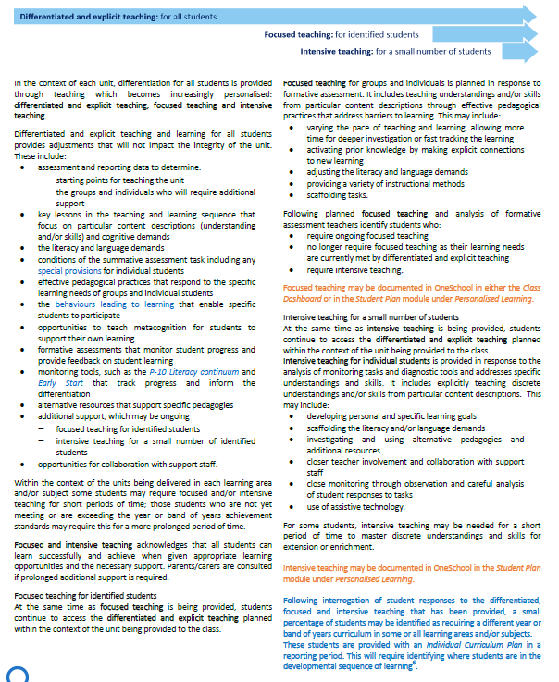
At Kurwongbah State School focused and intensive teaching are responsive to student data and sustain the integrity of the unit of work students are currently engaged in. Students engage is a specific program of learning with data regularly reviewed for student progress and to refine ongoing prevention and intervention strategies. Students engaged in focused and intensive teaching programs are identified through a team approach and in consultation with parents. Precise learning expectations, strategies and the monitoring of learning progress is a hallmark of this process.
Schools provide focused teaching for students who continue to demonstrate that they are not meeting year-level achievement standards or behaviour expectations.
Some students require additional learning response strategies to meet year-level expectations in a particular strand, mode, or part of a learning area/subject. For some students, focused teaching addresses more significant support/enrichment needs within the curriculum. Some students require additional scaffolding and response strategies to meet behaviour expectations.
Focused teaching responds to students’ needs by pre teaching/revisiting concepts and/or skills and using explicit and structured teaching strategies, in particular aspects of a learning area or behaviour skill. Focused teaching provides students with more opportunities to practise skills and multiple opportunities to achieve the intended learning and expected behaviour.
Focused teaching response to learning strategies at Kurwongbah State School are recorded in Personalised Learning in One School and may include and are not limited to:
Curriculum | Behaviour | Social/emotional
Co teaching  Focused small group pre teaching with teacher/ teacher aide  Focused small group revisiting of concepts with teacher/teacher aide  Small group learning readiness skill focus e.g. fine motor, gross motor, speech/ language  Enrichment and extension programs | Check ins and support with behaviour teacher and teacher aide  Individual Behaviour Support  Supported play and supported eating  Small group focused programs of approx. a term’s duration e.g. Play is the Way | Small groups e.g. boys/girls groups participating in a specific skill program of no longer than a term’s duration

Key documentation for focused teaching includes:
- Personalised Learning Plans and Support Provisions in One School
Intensive teaching for a small number of students
Schools provide support for a small number of students who require intensive teaching, following focused teaching, as they continue to perform substantially below, or above, year-level expectations in a learning area/subject or across the whole curriculum. A small number of students may require frequent individual behaviour scaffolding and response strategies reflected in an Individual Behaviour Support Plan.
Intensive teaching involves frequent and explicit instruction, with individuals or in small groups, to develop sequential mastery of basic concepts, skills and knowledge. Some students may require intensive teaching for a short period of time, for particular aspects of the curriculum or behaviour skills. Other students may require intensive teaching for a more prolonged period of time.
A small number of students may be provided with a lower or higher year-level curriculum in one or more learning areas. This is always done in consultation with parent(s) and requires an Individual Curriculum Plan (ICP).
Key documentation for intensive teaching includes:
- Individual Curriculum Plans: full and partial
- Individual Behaviour Support Plans
- Crisis Management Plans
- Complex Case Management One School
- Flexible Arrangements and Dual Placements

Legislation and Policies
The policies, procedures and practices at Kurwongbah State School are underpinned by our legal responsibilities as outlined in the Commonwealth Disability Discrimination Act 1992 (DDA) and the Disability Standards for Education 2005 (Standards) and meet state requirements for delivering the curriculum from Prep to Year 12.
The DDA makes it unlawful to discriminate against people due to disability and provides for the inclusion, protection and accommodation of all people with disability. Under the DDA, the term ‘disability’ is much broader than the six verified categories of Hearing Impairment, Vision Impairment, Physical Impairment, Autism Spectrum Disorder, Speech Language Impairment and Intellectual Disability. The term ‘disability’ therefore includes students with particular learning needs (verified and unverified) including difficulties with social learning, i.e. those with challenging behaviour.
For more information about disability refer to Appendix 2: Definition of Disability.
The Standards were developed to clarify the obligations of education providers under the DDA. Under the Standards schools are required to support students with diverse learning needs so that they can participate in education on the same basis as all other students.
The P–12 curriculum, assessment and reporting framework specifies the requirements for each Queensland state school in delivering the curriculum from Prep to Year 12 by:
- providing students with the required curriculum
- assessing, monitoring and capturing student achievement
- setting high expectations for each student and responds effectively to their current levels of achievement and differing rates of learning
- preparing students to exit schooling with the foundation for successful lifelong learning and participation in the community
- keeping parents and students informed of the students’ achievement throughout their schooling.
For more information and access to policies, refer to Appendix 3: Relevant Legislation, Policies and Documents
Appendixes:
- Roles and Responsibilities
- Definition of Disability
- Relevant legislation and policy documents
- Case Management Flowchart Draft 2020
- Differentiation Placemat (Maker Model)

Appendix 1: Kurwongbah State School - Roles and Responsibilities

Executive Team  Principal and Deputy Principals | - Ensure state legislation and expectations are embedded in policies, procedures and practices  - Are instructional leaders  - Model and uphold inclusive practices and decision making
Leadership Team  Executive Team, HODLs, HOC, Learning Engagement teachers and BM | Lead a whole school inclusive approach to student learning through:  - Ensuring alignment of the school vision and the improvement agenda  - Using evidence-based practices informed by the inquiry cycle for the targeted use of school resources aligned to the EIA  - Building the capability of all staff  - Regularly monitoring, reviewing and refining improvement strategies
Class Teacher | Class Teacher is responsible for all students within their class and will  - Maintain current knowledge of:  - Curriculum, assessment and reporting policies, procedures and practices  - DDA and Standards  - Evidence-based practices  - Know and understand the learning needs of individual students  - Plan and deliver differentiated programs and identify high yield strategies for improved student outcomes  - Collect, analyse and respond to evidence of student learning  - Use evidence based data to inform, plan or coordinate differentiated, focused/ intensive teaching with additional support from SST as identified
Year Level Team | Collective ownership of year level data, shared high yield strategies for Tier 1 learning and knowledgeable others who can provide feedback/ options for differentiation strategies to maximise student potential.
Student Engagement Team  HODLs, IEC teachers, SLP, E T, P Ls, BST | Student Engagement Team work with teachers by:  - Reviewing differentiation strategies, data and supporting evidence  - Developing Tier 2 response strategies  - Monitoring student progress over time to review the effectiveness of response strategies or new data
Paraprofessionals | Paraprofessionals support identified students by:  - Implementing evidence based programs as developed and directed by staff  - Recording and providing feedback to coordinating staff
Guidance Officer | The Guidance Officer supports students by:  - Undertaking further assessments to provide additional information  - Referring to medical agencies, community groups, government and non-government departments concerning students with specific needs when applicable  - Source additional funding and resources to support identified needs
Chaplain | The Chaplain supports identified students through the provision of pastoral care programs.
Regional Support | Regional support personnel work with school leaders to develop key capabilities to meet the identified student needs within the school.
Outside Agencies | Outside agencies work with students and/or staff to meet the identified student needs within the school.

APPENDIX 2: Definition of Disability

Under the Disability Discrimination Act, disability is defined as any of the following:
- Total or partial loss of the person’s bodily or mental functions;
- Total or partial loss of a part of the body;
- The presence in the body of organisms causing disease or illness;
- The presence in the body of organisms capable of causing disease or illness;
- The malfunction, malformation or disfigurement of a part of the person’s body;
- A disorder or malfunction that results in the person learning differently from a person without the disorder or malfunction;
- A disorder, illness or disease that affects a person’s thought processes, perception of reality, emotions or judgment or that results in disturbed behaviour;

This includes a disability that:

- Presently exists; or
- Previously existed but no longer exists; or
- May exist in the future (including because of genetic predisposition to that disability); or
- Is imputed to a person.

Appendix 3: Relevant Legislation, Policies and Documents

The Disability Discrimination Act 1992 http://www.comlaw.gov.au/Series/C2004A04426
The Disability Standards for Education 2005 http://www.comlaw.gov.au/Details/F2005L00767
DETE Statement of Expectations- Curriculum provision to students with disability http://education.qld.gov.au/curriculum/framework/p-12/docs/policy-disability.doc

DETE Inclusive Education Policy Statement http://education.qld.gov.au/schools/inclusive/index.html

P-12 curriculum, assessment and reporting framework
http://education.qld.gov.au/curriculum/framework/p-12/index.html

Supporting information: Individual curriculum plans
https://oneportal.deta.qld.gov.au/EducationDelivery/Stateschooling/Teachingquality/Documents/individual-curriculum-plans-supporting-info.doc

Individual Curriculum Plan edStudio
https://staff.learningplace.eq.edu.au/lp/pages/default.aspx?pid=1433884
The Australian Curriculum- Student Diversity
https://www.australiancurriculum.edu.au/resources/student-diversity/students-with-disability/
QCAA Catering for Diversity using the Australian Curriculum http://www.qcaa.qld.edu.au/downloads/aust_curric/ac_stud_diversity_fs.pdf

Appendix 4: Kurwongbah State School Case Management Flowchart
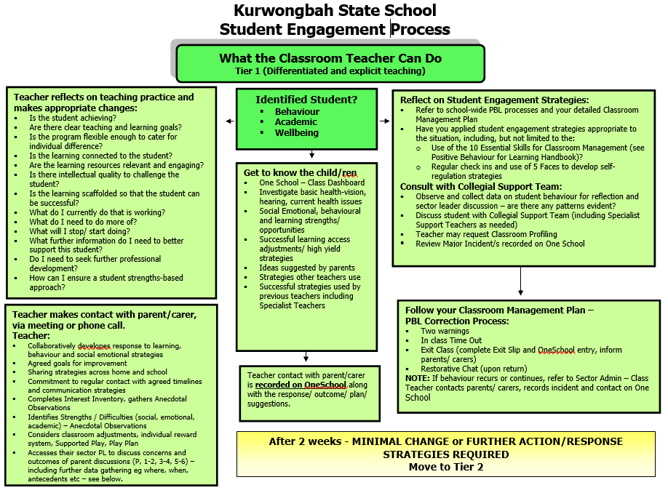
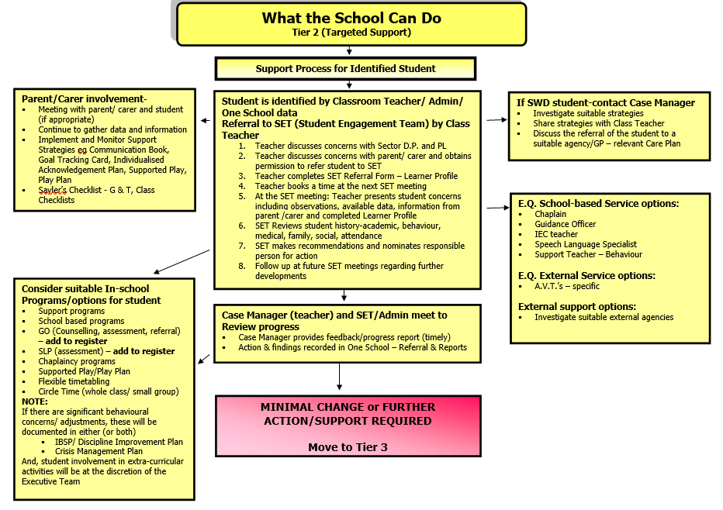
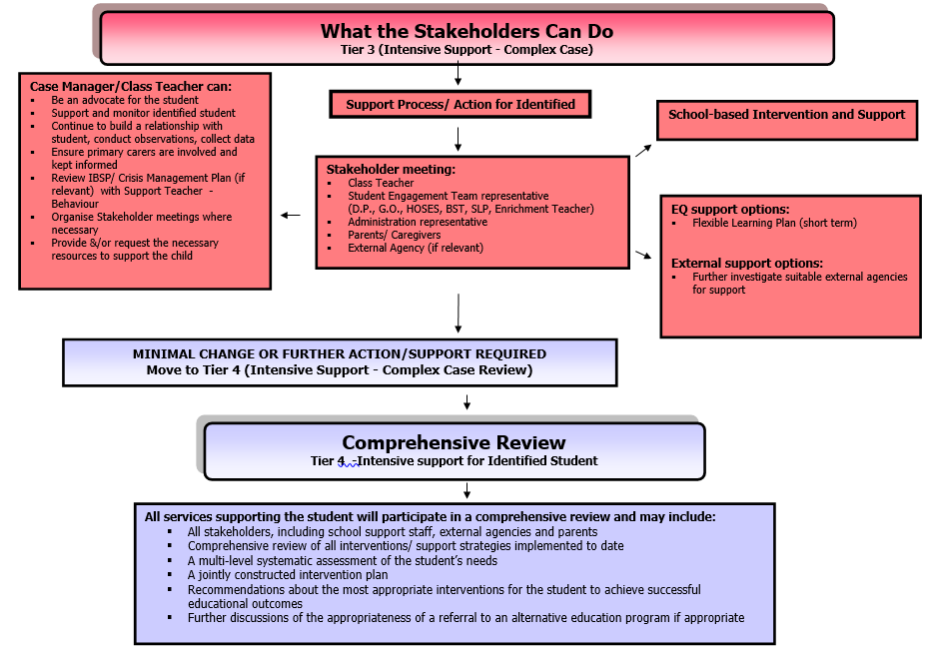
Appendix 5: Differentiation Placemat/ Maker Model
